**LAB # 6**

**Objectives:**

* To learn and understand the working of NAND gate and NOR gate

**Introduction to NAND Gate**

**74LS00 IC** contains four 2-input NAND gates. The function table and connection diagram for this IC are shown below:

**Function Table Connection Diagram:**

|  |  |  |
| --- | --- | --- |
| **Inputs** | | **Output** |
| **A** | **B** | **Y** |
| L | L | H |
| L | H | H |
| H | L | H |
| H | H | L |

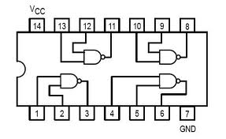

H= Logic High, L= Logic Low

**Introduction to NOR Gate**

**74LS02 IC** contains four 2-input NOR gates. The function table and connection diagram for this IC are shown below:

**Function Table: Connection Diagram:**

|  |  |  |
| --- | --- | --- |
| **Inputs** | | **Output** |
| **A** | **B** | **Y** |
| L | L | H |
| L | H | L |
| H | L | L |
| H | H | L |

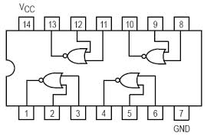

H= Logic High, L= Logic Low

**Question #1:**

Simplify the Product-Of-Sums Boolean (PoS) expression below.

http://sub.allaboutcircuits.com/images/14132.png

**NOR and NAND Implementation on logic trainer:**

**Question#2:**

Implement following expressions on **Logic Works** using **only** the **NAND gates.**

**(Use ICs to implement logics)**

1. **Z = A.B (b) X = A+B (c) XNOR**

**Question#3:**

Implement following expressions on **Logic Works** using only the **NOR gates.**

**(Use ICs to implement logics)**

1. **Z = A.B (b) X = A+B (c) XOR**

**Question # 4:**

For the Boolean function $F1(A,B,C,D)=\sum{m(2,4,12,14)}$ perform the following tasks:

1. Find truth table
2. Find minimal SOP expression for Boolean function $F1$ using K-map. Draw K-map.
3. Draw the resultant expression obtained in part (b) and implement on **Logic Works** using **only NAND gates.**